VPC creation

STEP1: Create VPC, with name and CIDR range

Note : If you select VPC and more option, then your VPC with subnets will get created in 2 AZ’s

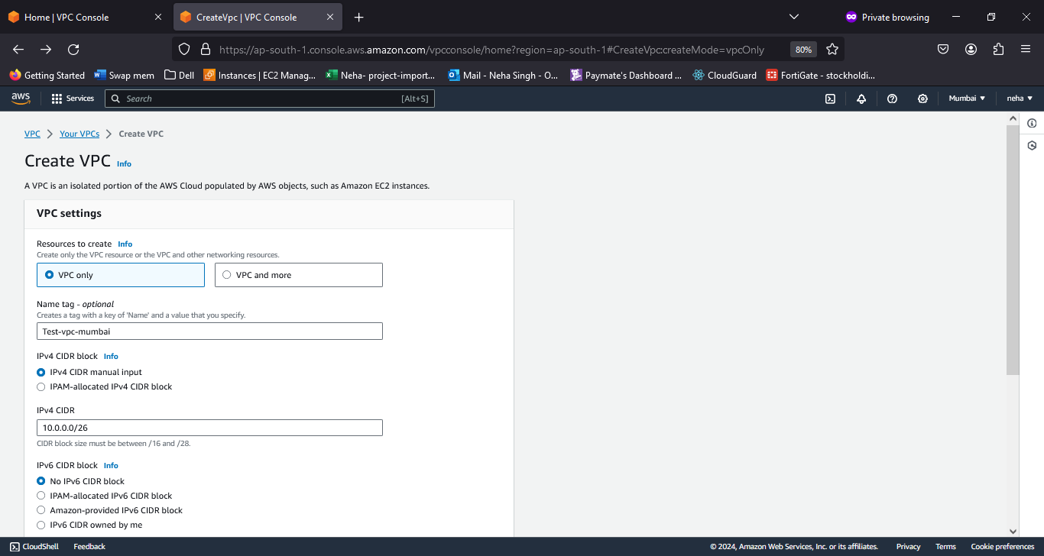

Route table gets automatically created

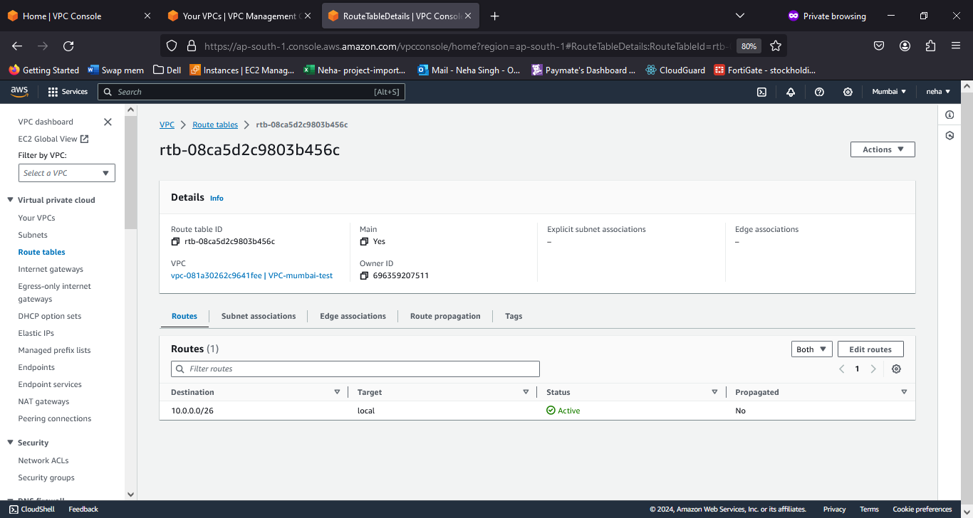

STEP2: Create Subnet (2 public subnet, 2 private subnet) total 4 subnet so 10.0.0.0/26 =64 Ips so 16 Ip each subnet. The CIDR for each subnet will be like 10.0.0.0/28, 10.0.0.16/28, 10.0.0.32/28, 10.0.0.48/28 ----- 32-28=4, 2^4= 16 Ip’s each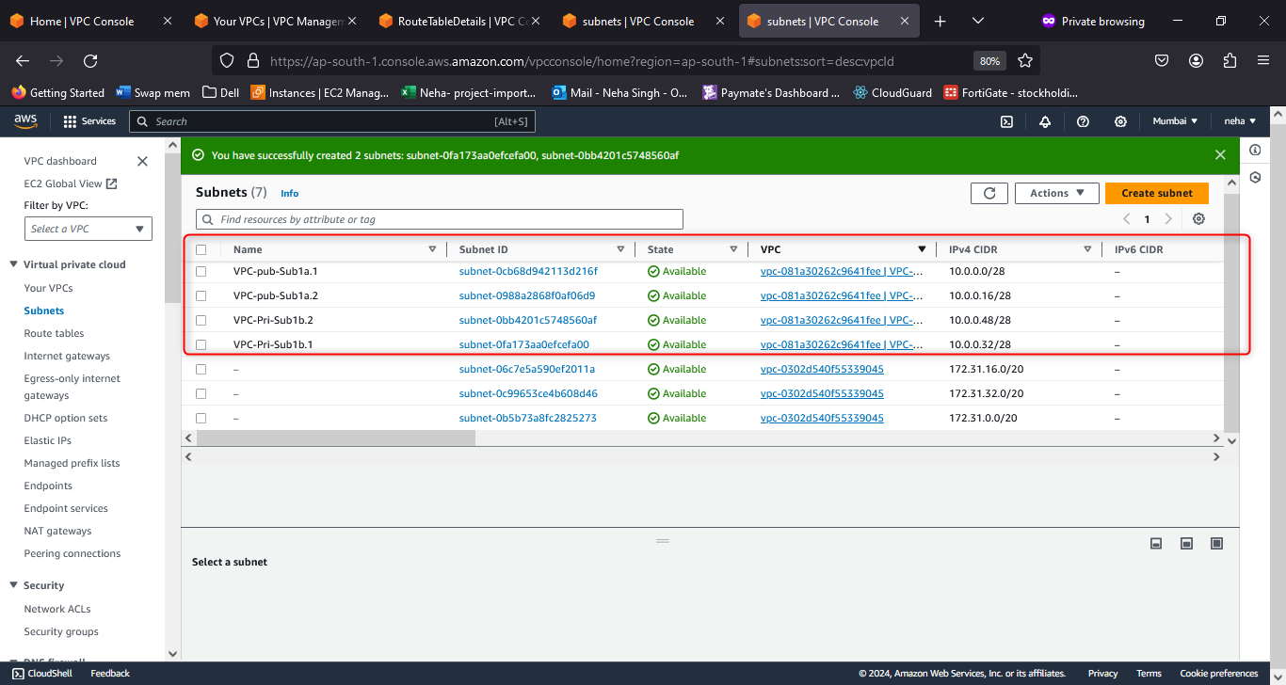

STEP3: Create a 2 Route tables each for Public and Private subnet (For Private subnet, we need Internet Gateway)

In My case I will create a separate route table for private subnets and I will associate only private subnets

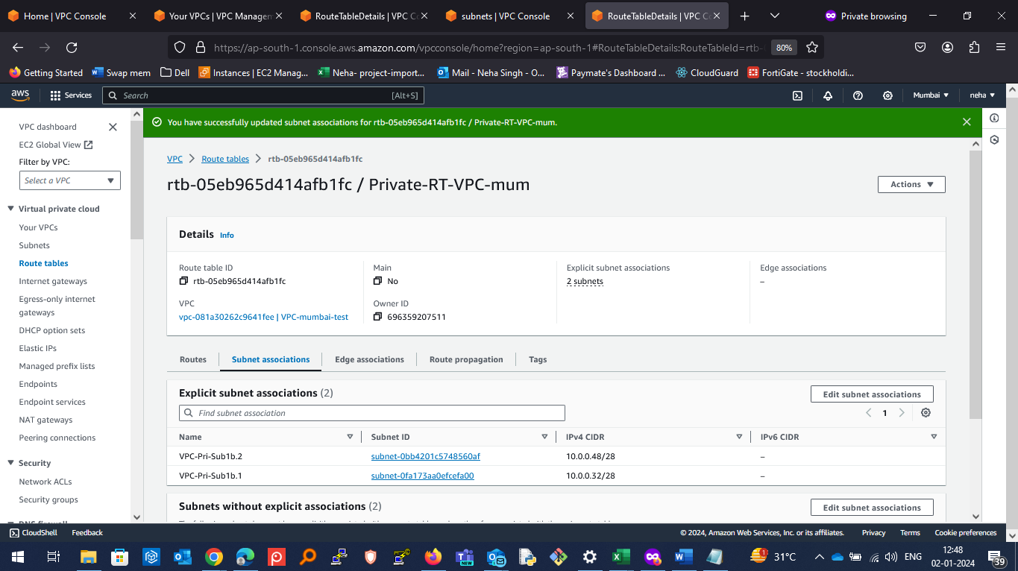

Later I will associate my public subnets with Original route table

STEP4: Create Internet Gateway and attach it to Main or Public Route table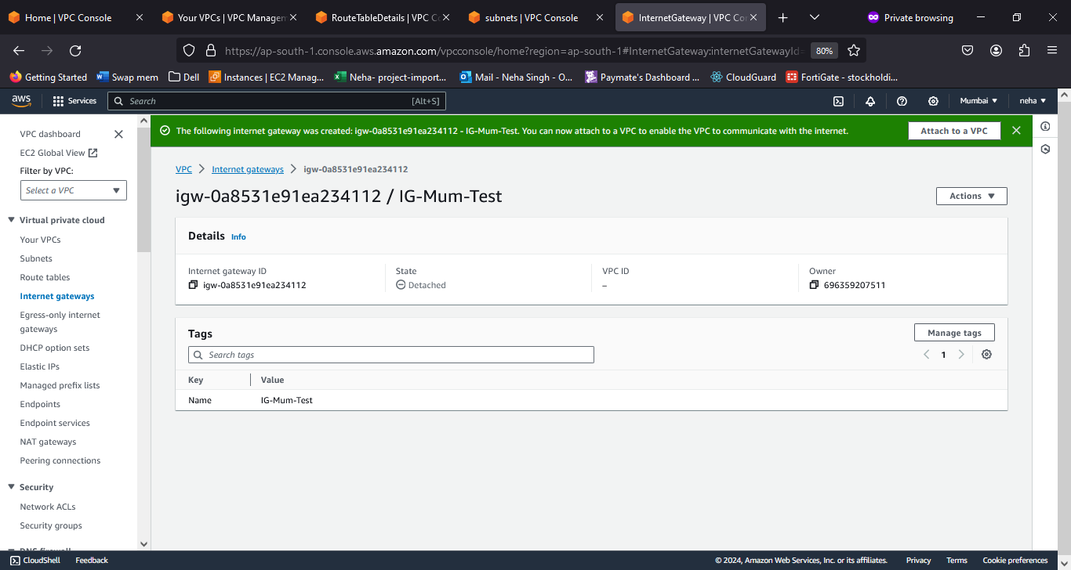

Not Add the IG to main Route table

STEP5: Create NAT gateway to give internet access to private subnet

We need to create the NAT gateway in same AZ where the Public Subnet is created.

Next we need to add the NAT gateway to Private Subnet’s Route table.

Create Instance in the VPC and attach the SG and Subnet accordingly.